Lab 4 - Lists

Instructions
- Answer the below question in the boxes if needed.
- For coding exercises, code on your computer and zip all your code before submission.
- Please submit the assignment after you finish.

Part 1: Unordered List
Steps:

- Go to VS Code and open the folder that we created in Lab 1
- Create a new html file and name it as “lists.html” inside the folder.
- Add HTML code inside the body tags and try to create a page that looks like the screenshot below.

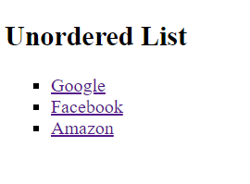

- The href for the 3 links in order are as follows:

  - https://www.google.com/
  - https://www.facebook.com
  - https://www.amazon.com/

Part 2: Ordered List

- Below the unordered list we created in Part 1, add HTML code to create an ordered list like the one below. (Hint: Make sure you do it with an ordered list and the list doesn’t start with 1).

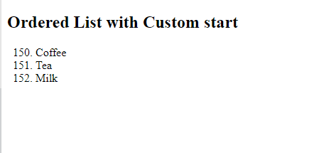

Part 3: Nested List

- Below the ordered list we created in Part 2, add HTML code to create an nested list like the one below. (Hint: It is a 3-layer nested list).

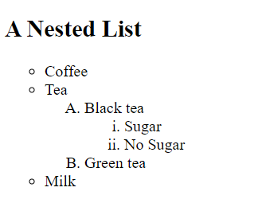

- Zip your final code with all three lists (from part 1, 2, and 3) and submit.

